ANNEX 2: MINUTES OF THE FOLLOW-UP COMMITTEE MEETINGS

BIOSERF
Follow-up Committee Meeting – Brussels

30 September 2011

Contrat n° SD/AR/03A

List of participants:
BIOSERF : Arne Baert (UGent), Marie-Odile Beudels (IRSNB), Nicolas Dendoncker (FUNDP), Louis François (ULg), Claire Halleux (FUNDP), Alain Hambuckers (ULg), Franck Trolliet (ULg)
BELSPO: Moshine EL Kahloun
FOLLOW-UP COMMITTEE: Hans Beeckman (RMCA)

- Introduction by M. El Kahloun
M. El Kahloun welcomes the participants and reminds the main goals of the follow-up committees (FUC) and some aspects of their organisation. FUC have the objectives to bridge gaps between scientists and policy makers. They have a legal base as stated in the agreement and they are composed on a voluntary base. FUC have to be organised every six months and could be located abroad using part of the networking budget. The documents which will be presented must circulate one week before and a report must be produced and disseminated by the coordinator in the next two weeks. It is asked to reach a minimum of five actually present members. M. El Kahloun suggests inviting the coordinators of the other SSD projects.

- The BIOSERF project by A. Hambuckers
A. Hambuckers introduces the new researchers of each institution to the participants. He reminds the objectives of the project, its location in a 80,000 sq. km WWF Landscape, and the tasks to be accomplished in the operational work packages (WP1, WP2, WP3, WP4, WP5).
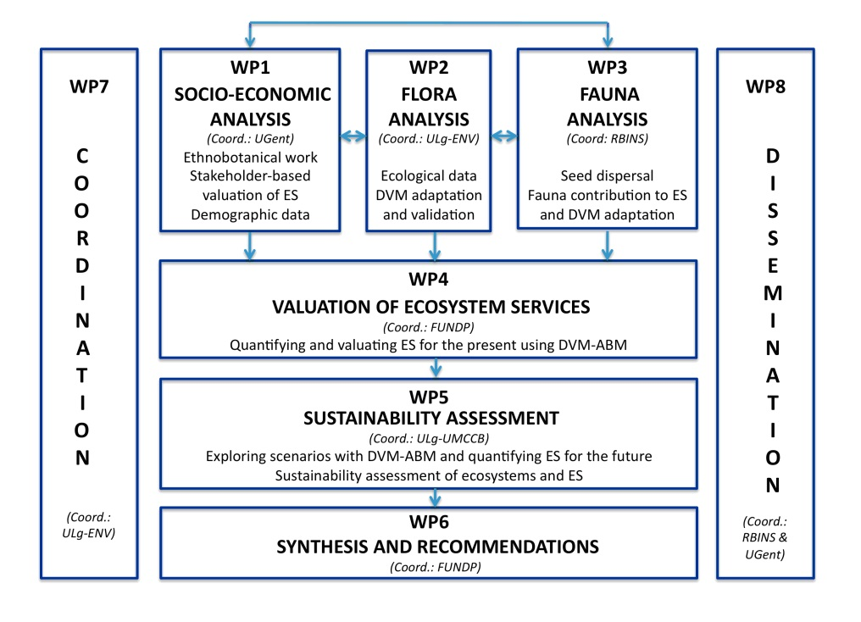
- WP1 – Socio-economic analysis by A. Baert
The idea is to gather as much information and clues on the local drivers of land use decision-making as possible. This will need ethnobotanical-anthropological work consisting of interviews, mapping exercises, and field walks.
Human activities threatening the local landscape and values include unsustainable agricultural practices, hunting and bush meat trading, uncontrolled logging, over-fishing, etc. coupled to certain feedbacks such as immigration pressure, conflict and disease and lack of governance. We can distinguish direct (household level) and indirect (governance level) drivers of land-use change. A combination of driving forces (culture, demography, natural variability, etc.) leads to certain dominant pathways of land use affecting ecosystem services.

- Research questions: What are the important environmental, economic, institutional and social patterns? What are the driving forces/patterns for land use and land cover change in the study area? Understand how human activities affect key species or functional groups that provide ecosystem services? Understand which populations, species, functional groups, habitat types collectively produce ES (ES providers).

The lake Tumba-Mai Ndombe landscape is characterised by a variety of vegetation types, a forest-savannah mosaic south, swamps and seasonally inundated forest north and mixed zones in between and many different groups of people reside in the area. Because of this variety we will focus our research around a cluster of villages both North and South in minimum two different field missions. The first mission is planned end of January.
There’s a certain spatial extent of the coupled human–natural system that strongly influences biodiversity/land use. We need to define this zone of interaction (Defries et.al., 2010) around a village taking into account possible migration corridors.

- Tasks and methods: After having defined the study area and subsequent villages/settlements, we will define a stakeholder typology and characterize demographics. Actors in land use differ depending on lots of variables. Data will be gathered using a combination of methodologies including focus groups and interviews with household communities and key informants. Information on household size, income, crop preference, land availability, market strategies, income generating activities, etc. will be gathered this way.
The analysis of the forest-human interactions is the next step. Data on local ecological knowledge, past and current land use, seasonal settlements, ownership and use rights, cultural and ceremonial practices, hunting trails, animal husbandry, etc. will be collected using methods varying from board games, field walks and seasonal calendars to community mapping and others. We will also try to link certain variables such as population size, proportion of migrants and distance to market for instance with forest fragmentation or other land use changes.
The selection of key ecosystem services will be done using the hotspot mapping technique. This method allows the identification of important/valuable sites for certain social values (subsistence, leisure, ceremonial, commercial, among others) as well as possible conflict sites (foraging vs. logging). Hotspot mapping involves people delineating important areas of interest on high quality orthographic images. This data will then be transferred into a GIS application using transparent cell grids, GPS coordinates and field notes. Walks in the field with specialised guides, armed with a GPS system will help geo-referencing the information obtained. When hotspot areas are identified, we can check what key species or functional groups provide the ecosystem services attributed within that hotspot area, using the consensus method, subjective allocation or uses totalled method (Martin, 1995; Alexiades, 1996; Cunningham, 2001).

- Questions
- Is it possible to integrate land use map with social map?
By using satellite images, the investigator will ask individually to people to indicate where there are cutting wood, collecting fruits, etc. However, people could be unable to recognize their land on picture because they are not familiar with this perspective while they know the land very well. The alternative method will be to go in field with people and to GPS record the locality with the use. This is much more time consuming and it remains difficult to get quantitative results.

- WP2 – Flora analysis and WP3 – Fauna analysis by F. Trolliet
After a preliminary mission in the landscape in the course of the June to July to evaluate feasibility aspects, an operational mission is planned end of January to start data collections.
- 5 tree species, namely: Anonidium mannii, Gambeya africana, Myrianthus arboreus, Staudtia stipitata and Enantia chlorantha, will be studied. Those species are all source of ecosystem services (food, medicinal plants, wood…). They are all large seeded (length of 1 cm or more) meaning that their dispersal is dependent on the action of large frugivore vertebrates.

- Objective 1 is to evaluate the dispersal capacity of each species. We will need to define the number of seeds produced, the disperser community, and the number of seeds dispersed.
Methodology - We will set up 5 fruit collectors of 0.4 m² below 3 target trees per species. The collection of fruits will be done every two weeks. Then, we will make observations thanks to binocular and camera traps to define the community of diurnal, nocturnal, arboreal and terrestrial dispersers and predators, as well as the feeding behavior of each animal species. This will allow us to define if the seeds are predated, spat or swallowed.

- Objective 2 is to define the dispersal kernels of each tree species. A dispersal kernel is defined as he probability density function that a seed is deposited at a given place.
Methodology - We will drive a literature study and define for each disperser species, (1) the seed retention time in the digestive tract and (2) the movement ecology (home range) size and habitat use.

- Objective 3 is to study the seed traits such as the germination rate and the dormancy type.
Methodology - We will set up germination experiments in natural medium and check weekly for the germination status. We will define the dormancy type (morphological, physical and physiological) for each species using respectively a microscope, imbibitions tests and mean germination time.

- Objective 4 focus on one species, Anonidium mannii, and aims at studying the dispersal capacities in the context of forest fragmentation. The hypothesis here is that smaller fragments would know a higher defaunation pressure, which is likely to alter the seed dispersal capacities
Methodology - We will select 10 forest fragments of different size in order to obtain a continuous gradient of size. As the fragments are more or less connected to each other, we will consider that a fragment is isolated where its corridor width will be less than 800 meters (zone with negative impact of edge effect). Using the methodology of objective 2 (observation with binocular and camera traps) we will redefine the dispersal capacity of the tree species in this fragmented ecosystem.

Trough objectives 1 to 3 we will collect data on the regeneration capacity of the 5 tree species in a continuous forest, which are essentials to feed the models. Objective 4 will give complementary and more precise data for the models and help us to highlight the potential effect of forest fragmentation which is also an essential goal of the project.

- Questions
- The exposed methods explain how one will study the effect of human pressure on the process of seed dispersion, but what about the climate?
The effect of climate change will be assess through the use of the model after calibration with the present conditions
- How are evolving the savannas in the landscape?
There are places where forests are in progress and other ones where there are regressions. The effect of ranching is obvious. One could observe specific tree species colonizing savannahs or secondary forests.
- How were selected the 5 tree species to be studied?
The seeds have to be large enough to be transported by birds and large mammal species (> 1 cm). The species have to produce goods for people but this is difficult because the uses changes from villages to villages. They have to be relatively easy to find in the landscape.
- They are no consideration about diversity in the selection of the 5 species?
The 5 selected species belong to 5 different plant families and do not live in the same environment. But indeed, 5 species is too few to go about the matter of biodiversity. Here the focus is on the characterization of processes and it is not possible to include more species in the analysis.

- The CARAIB dynamic vegetation model (WP2, WP3, WP4, WP5) by L. François
The objectives of the presentation are to explain where the model will be used in the project and how it works. The work with the model has not yet started according to the timetable.
- The model will be adapted and used to simulate the growth of the 5 selected species in the framework of the rest of the vegetation also grown by the model in WP2.
- The model will integrate some effect of the fauna according to WP3.
- When the model will be ready, it will be coupled with the ABM in WP4 to quantify the ES.
- Through various scenarios (climate combined with socio-economic) for the future, the coupled models will simulate how ES could evolve and if the forest would be able of regeneration.

A dynamic vegetation model is dynamic in time and space. It computes explicitly various physical, biogeochemical and ecological processes like soil hydrology, vegetation physiology or nutrient budget. For this reason, but depending on the scale of its application, it needs some adaptations, e.g. to plant species, to dispersion characteristics. In addition, it could be upgraded with new processes, e.g. with some germination aspects or the translation into ecosystem services.
The inputs of the model are soil texture, plant constants, monthly or daily climate variables (air temperature, precipitation, percentage of sunshine hours, air relative humidity and wind speed), and CO₂ partial pressure. The outputs are numerous: parameters of water budget, energy, plant growth, etc. Therefore it is possible to observe the vegetation changes under the various hypotheses.
The model used at continental scale with a 20 km resolution grid already simulated a mix of savannas and tropical rain forest on the selected region. The increase of resolution to the kilometre and the use of the new fire module will directly enhance the precision of the simulation. Gains will also come with the upgrades, the local adaptations and the inclusions of crops.

- Questions
- How will the model be adapted to the local flora?
The best option will be to create local biological affinity groups of plants (BAGSs). The method consists in establishing lists of plant species representative of the various habitats. For each species, one looks for occurrences (coordinates or localities) in atlases, flora or online databases like GBIF. The coordinates permit to obtain bioclimatic limits which produce the BAGs through discriminant analysis. These objects will make the background vegetation for modelling in which the 5 ES species will be grown.
- Does CARAIB include land-use?

Not yet, but it will do according to the project when coupled with the ABM
- Will CARAIB simulates effect of climate change only for the BAGs?
No. It will simulate the growth of the BAGs and of the 5 species under the various hypotheses of climate change and CO₂ partial pressure. The BAGs are necessary to produce competition for space and resources (light and water in the current version of the model). Otherwise, the 5 species alone would occupy all the allowed virtual space. The background vegetation is computed through the BIOME routine, which compares the net primary productivities and leaf area indices of the differents BAGs present on the grid cell. It thus adds the information of the vegetation type and allows to map this information. Some species are able to grow in savannas or secondary forest or else. In addition, it is possible to impose an additional human stress like fire.

- How work an Agent-Based Model (ABM) (WP4, WP5) by N. Dendoncker
The objectives of the presentation are to explain:
- What kind of agent-based model (ABM) should we implement in BIOSERF?
- How should this ABM be linked to the dynamic vegetation model (DVM)?

An agent-based model (ABM) is a representation of a complex social-ecological system in which agents act and interact with each other and with their environment. The results of these interactions may lead to emergent properties at the landscape level. These properties are emergent because they cannot be envisaged by just looking at the different components of the model. The result of these interactions on the landscape may generate feedbacks, which in turn modify the agents’ decision processes. In the BELSPO funded VOTES project, an ABM of agricultural decision-making is coupled to a dynamic vegetation model (DVM) for a case study area of about 200 km² in Brabant-Wallon, Belgium. The DVM models the growth and yields of a series of crops that the different farmers decide to plant or not.
Such a coupled ABM-DVM could be applied in the context of BIOSERF, but there are several practical limitations. First, the extent of the study area and the resolution of the DVM the lake Tumba Landscape are relatively large to be modelled with such a modelling framework, because the number of agents to be modelled is big. Second, the availability of socio-economic and biophysical data is limited. Third, the issues at stake: in a forest landscape, each land manager is not directly nor easily linked to a specific patch of land.
In such case, some authors argue that a post-normal posture is required (Functiowitz and Ravetz, 1994). This post-normal structure implies a move away from the expert posture that is usually applied in such projects. An expert posture is valid and best used when uncertainties are rather low. In a post-normal posture, there should be a dialogue between scientists, citizens and decision makers. A post-normal posture will be taken in BIOSERF. In terms of Ecosystem Services (ES), the ABM essentially represents the demand side (how much ES do local citizens consume?), in relation to the supply side modelled by the DVM. We would like to implement an ABM that broadly follows the principle of companion modelling (commmod) initiated by the CIRAD (www.commod.org). A commod approach requires that all ideas at the basis of modelling can be challenged; it also means that there should be no implicit hypothesis from the scientist at the start of the study; the scientists should consider the impact of the research on the study area from the start of their research.
Particular attention should also be given to validation, including social validation. This modelling will take place at the village level. It will allow the confrontation of point of views, the stakeholders will try and understand the interdependencies and discuss synergies and trade-offs between ES (Barnaud and Antona, 2010). We will use scenarios to capture uncertainties.
A potential study site (village) should be selected. This selection will depend on the results of WP1; it could for example, be the results of the hotspot mapping that will be obtained in WP1. Alternatively, a zone in which there is a conflict between ES use and biodiversity protection could be selected. More generally, the study area should be representative enough of the ongoing processes of change that characterize the larger lake Tumba Landscape. The selection of the studied village will be discussed with all project partners and the local WWF offices. The link with the DVM will be explicit in that the ABM can be calibrated using results of the DVM. The DVM may also provide useful hints on the evolution of ES through time, which can be used for scenario modelling using the ABM. The issue of the representativeness and/or generalisation of the results to the whole landscape scale will need to be addressed in collaboration with the other projects partners and projects’ stakeholders including the follow-up committee.

- Questions
- A participative approach is interesting for such an area but what about the scaling problem with the ABM but also with the other approaches? The plant-animal interactions studies, CARAIB, the socio-economic analysis, the ABM don’t work at the same scales?
Indeed, it will not be possible to have a “statistic view” of the whole landscape to feed the ABM. The data of WP1 will be case studies and use for building scenarios at the Landscape scale owing to ecological diversity, variety and intensity of human pressure. However, the teams of the institutions involved in BIOSERF are working in close collaboration. For instance, the field work of WP1 of ES and sociology data collection will be made jointly by C. Halleux (FUNDP) and Arne Baert (UGent) to feed the ABM (N. Dendoncker). The plant-animal interaction study (F. Trolliet) in WP2 and WP3 has the objective of obtaining the dispersal kernel to feed CARAIB (L. François) but takes care to study interaction with human by including an analysis through the fragment of the forest, to see how the processes are altered by defaunation. The adaptation and the coupling of CARAIB and the ABM precisely have to manage the scale differences of the produced inputs and outputs.

Alain Hambuckers

The coordinator of the BIOSERF project

BIOSERF
Follow-up Committee Meeting – Brussels

30 March 2012

Contrat n° SD/AR/03A

List of participants:
BIOSERF : Roseline Beudels (IRSNB), Nicolas Dendoncker (FUNDP), Louis François (ULg),à Alain Hambuckers (ULg), René-Marie Lafontaine (IRNSB)
BELSPO: Georges Jamart
FOLLOW-UP COMMITTEE: Gregory Claessens (WWF Belgium), Adeline Fayolle (ULg), Joseph Smitz (ULg),

- Introduction: The BIOSERF project by M. A. Hambuckers (ULg-ENV)
A. Hambuckers welcomes the participants. He introduces the network’s participants, reminds the framework and the goals of the project, and explains the scheme of work packages showing the organization of the tasks to be accomplished (see report 1).

- WP2 – Flora analysis and WP3 – Fauna analysis by A. Hambuckers (ULg-ENV)
In WP2 – Flora analysis, the Task 2.1 – Selection of five ecosystem service (ES) related species indicators of forest change, have been considered. Five species (Staudtia gabonensis, Annonidium manni, Chrysophyllum lacourtianum, Myrianthus arboreus and Annickia chlorantha) have been selected from field observations and literature analysis. For Task 2.2 – Collecting ecological data on the five tree species, species abundance, biomass, and landscape analysis will come from another project in the area managed by J.-F Bastin under the direction of J. Bogaert of ULg. Collaborations are established and more information than expected will be available. Fieldwork will concentrate on the estimation of germination traits, dormancy according to Baskins and Baskins (2004), and recalcitrance –viviparity according to Farnsworth (2000) (see figure below). The protocols involve simple experimentations or observations such as testing viability, embryos morphology, median length of germination time or seed rehydratation. The objective is to examine significant samples of species from the savannas, the secondary forest, and the climax forests (terra firma and swamp forests).
In WP3 – Fauna analysis, it was decided to study only two of the five selected species (Staudtia gabonensis and Chrysophyllum lacourtianum) for animal interactions (seed dispersal), after a long discussion with P.-M Forget of the Muséum d’Histoire Naturel de Paris, one of the world leader in this field. First, it appears necessary to intensify the observation effort on more trees per species (at best, 10 trees per series) than previously thought to get satisfactory statistical results. Secondly, there are already results on Staudtia and Chrysophyllum species from the neotropics. The same animal communities do not disperse Staudtia and Chrysophyllum species owing to characteristics of their fruits. Thus, a very pertinent question would be to test whether the same process applies in the paleotropics. Thirdly, the idea of studying the edge effect on the process would be too difficult because the selected species are rare in the edges, artificially maintained by man-induced fires. Finally, the design will be on the one hand to compare the two species in the same place and on the other hand to compare Staudtia gabonensis in another place with contrasted hunting pressure, the main perturbation to consider at this level of the forest regeneration process.

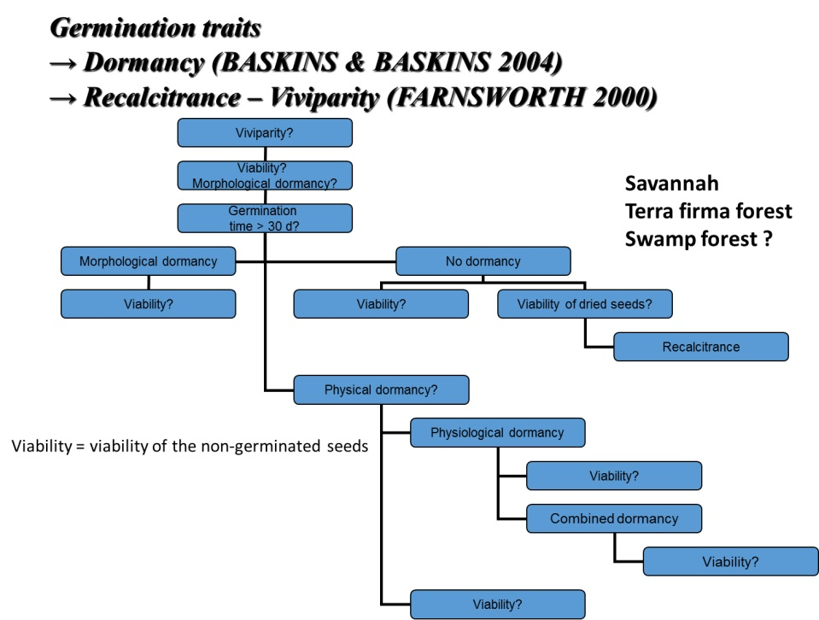

- Fauna analysis at landscape level by R. Beudels (IRSNB)
According to the project, the IRSNB team will study The contribution of fauna to ES Fauna sub- module will be developed for the DVM. With the followingsspecific tasks: (1) ROUGH ESTIMATE OF THE ABUNDANCE of the main animal species (functional groups), (2) IDENTIFICATION/QUANTIFICATION OF MAJOR INTERACTIONS between fauna, vegetation and ES”. The third task “(3) IMPLEMENTATION OF A MODULE FOR ANIMAL” will be mainly managed by the UMCCB team.
Main traits of the Lac Télé – Lac Tumba Landscape
It is the largest area of wetlands of Africa mainly covered (>80%) with flooded and swamp forests. These forests host three large primate species (gorillas, chimpanzees and bonobos), which is unique in the world. They have an enormous value for biodiversity conservation but also as hydrological resources for local communities and as energy production for people living downstream
The huge biological value of the area could be explained by a rather low human density but also by the fact that some communities keep their traditional systems of natural resources management. Otherwise, this is difficult to travel trough the swamp forests, which limits poaching but favours the exchange up to the cities following waterways. Logging only concerns terra firmae forests.
To obtain results comparable with surveys conducted elsewhere, we will use standardized methods for data collections. In particular, we will apply the methodology of inventories developed by Hart & Hart (2010). Their specific objectives are summarized in the table below.

 | A) Determine distribution and abundance of fauna | B) Habitat evaluation | C) Anthropic occupancy and impact evaluation
1 Exploration | Area distribution | Main forest types and geographic gradients | Villages, settlements, footpaths, tracks and forest use signs
2 Inventory | Density and abundance | Relationships between habitat types and fauna | Impacts of hunting and logging
3 Faunal  focal Area | Use of production and degradation rates of bonobos nests (estimations in the Malebo region in the framework of a ULg-IRSNB doctoral thesis) to compute bonobo density. | Characterisation of areas with high density of large fauna and avi-fauna. Seasonal variations of their use by fauna | Identification of individual hunters and evaluation of their main activity areas

The image below gives an example of a three level subdivision for the Réserve Naturelle de Lédiima
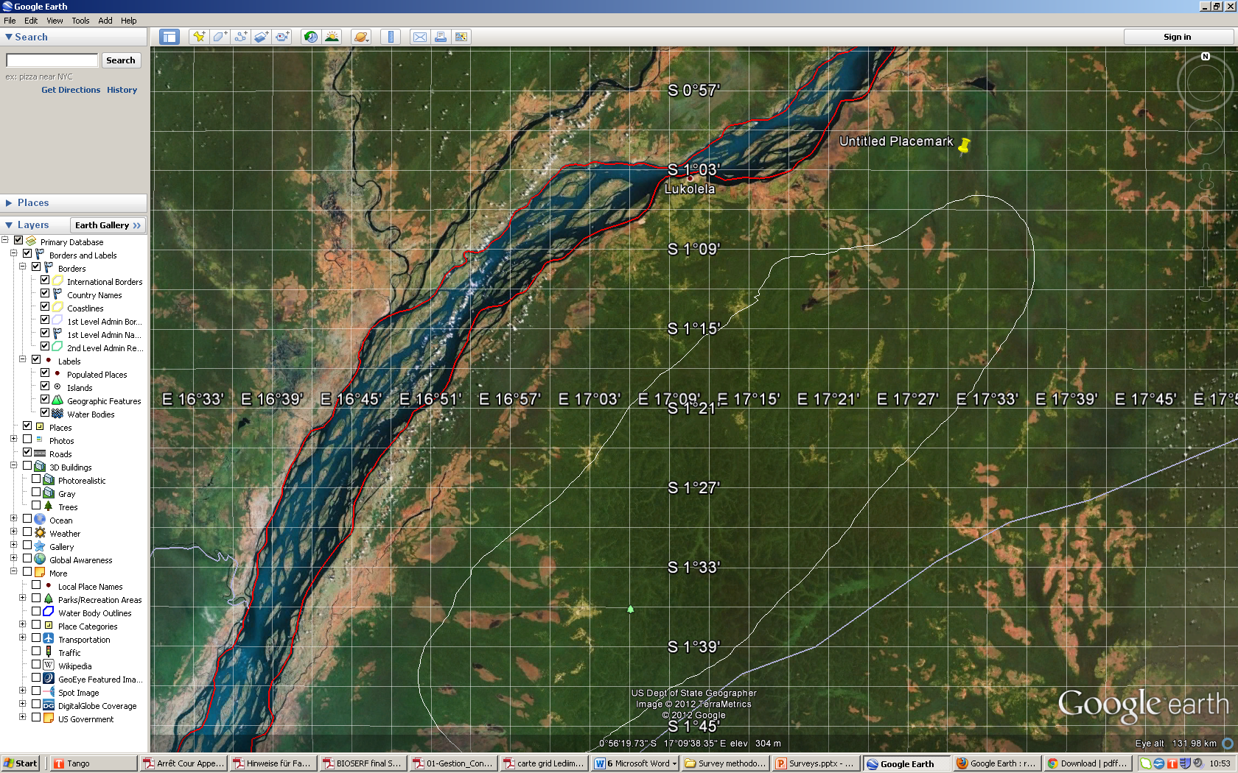

- The CARAIB dynamic vegetation model (WP2, WP3, WP4, WP5) by L. François (ULg-UMCCB)
Within BIOSERF we use CARAIB, a dynamic vegetation model (DVM), to describe how vegetation in the WWF Landscape will respond to climate and human pressure changes in the future. The CARAIB model was presented in the first FUC meeting of BIOSERF. A small summary of its structure and its use within the work packages of BIOSERF was again presented for the participants who could not attend the first meeting. CARAIB is a state-of-the-art dynamic vegetation model with various modules describing (1) soil hydrology, (2) stomatal regulation and photosynthesis, (3) autotrophic respiration, plant growth and mortality, (4) litter and soil carbon production and decomposition, (5) competition between plant types and biogeography, (6) wildfires, and (7) seed dispersal and plant species migration. The last module is still in construction. Within BIOSERF, CARAIB will be improved to better describe the dynamics of tropical forests and savannas in the study areas. Fires are a key factor in this dynamics, as well as the dispersal of tree seeds by the fauna. The model will be adapted to describe the 5 species that have been selected in the project and for which data will be collected during field campaigns in the area. One of the main objectives of the project is to couple CARAIB to the agent-based model (ABM) developed by FUNDP.
Since the last meeting, some transient simulations of the DVM at low resolution (0.5°x0.5°) have been performed over the whole territory of DR Congo between 1950 and 2100, in the framework of the IPCC scenarios A2, A1B and B1, using as inputs climatic fields from the ARPEGE-Climate model. Under the present-day climate conditions (1961-1990), the southern part of the landscape exhibits substantial changes in precipitation over the year, corresponding to the alternation of a wet and dry season. The model shows a significant decrease in soil water during the dry season. As a result, the biome shifts from tropical rain forest in the northern part of the landscape to tropical seasonal forest in the south. This result is to be compared with a transition from rain forest to savannah observed on the field. Thus, the biome shift is weaker in the model, although the location of the transition is correctly predicted. Possibly, less intense fires in the model, due to the neglect of human-induced fires in this large-scale version of the model, may explain this less abrupt biome shift compared to the observation. For the future, some results were illustrated for the A2 scenario. Under this scenario, a huge warming of ~4°C between in the period 2071-2100 compared to 1961-1990 combines with significant reduction in precipitation during most of the year to provide strong reduction in soil water in the CARAIB hydrological module (fig 1). By contrast, the net primary productivity of the forest slightly increases (by 100 to 200 g C m⁻² yr⁻¹), because the CO₂ fertilisation of photosynthesis overcompensates the effect of soil water reduction.
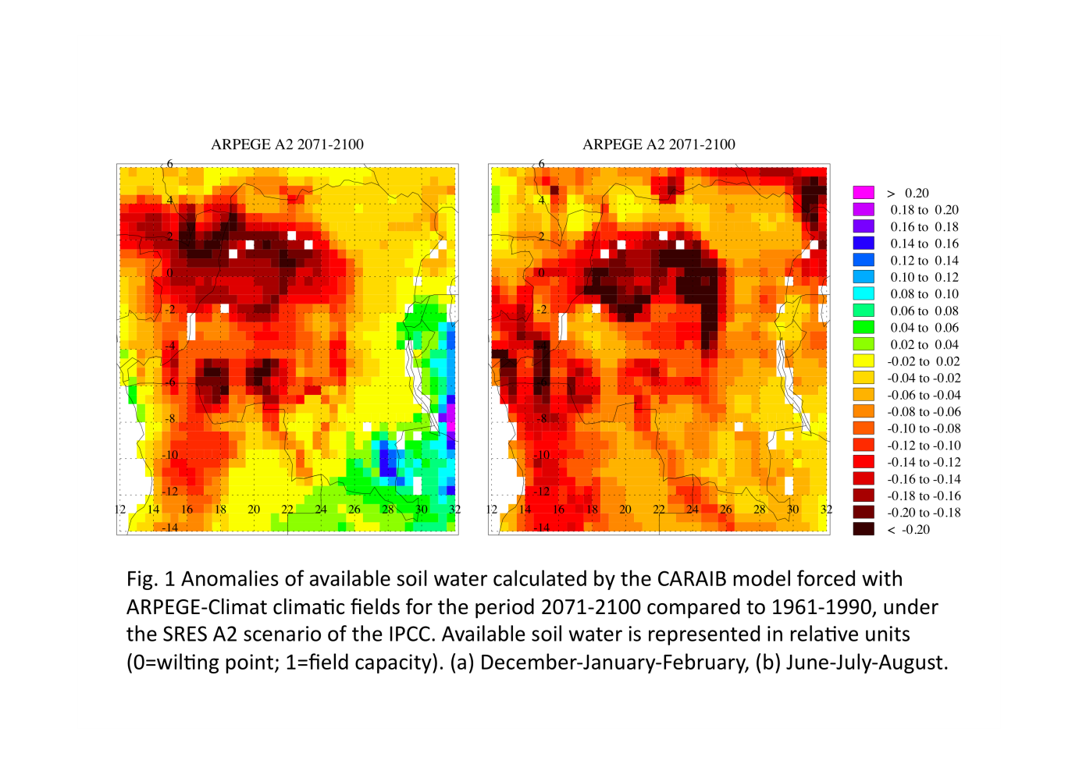

- Field work of WP1 by N. Dendoncker (FUNDP)
In collaboration with WWF-Mbandaka, Claire Halleux and Arne Baert have achieved a vast socio-economic survey in relation to WP1. Thirty-four potential investigators have been trained, out of which 24 were finally selected to conduct the survey. They have been split into 8 teams of 3 investigators (among which 2 will act as supervisor and 6 as team leaders). The survey has been conducted during the last weeks of March and first weeks of April. The study area is the triangle of Ngiri.
In the first place, the 71 villages of the area will be surveyed in this way: one questionnaire at the village level (focus groups will be made) and individual surveys completed by 15% of the heads of households (on average 25/village). Two main axes were established, 4 teams will be focus on each axe. The surveys are to be filled in Lingala and have also been translated into French. The focus group survey (1/village x 71 villages) includes about 100 questions, many of them being open ones; while the individual survey (1/family x +1700 families) is mainly based on closed questions (about 150) in order to ease the data analysis.
Logistic aspects are major constraints for the good development of the analysis: 2 days by boat from Mbandaka are necessary to join the place were surveyors will start. Logistics aspects are in charge of WWF while the surveys have been conceived and translated by the scientists of BIOSERF. Data analysis will also be supervised by BIOSERF members.
From mid-April onwards (when the first completed surveys will be made), trainees from a superior institute in Mbdanaka will encode data in computer files conceived by BIOSERF members. This work should be complete by the end of May. Data will then be analysed and results shared with WWF and local communities. There is also the possibility to organize a meeting with provincial authorities at the end of Octobre to share the results.
Objectives of the survey:
In an area within which data are extremely rare, the main objective is to gain a representative overview of the inhabitants of the study area (lifestyle, activities, revenues, resources, land use, availability and evolution of natural resources, adaptation strategies, infrastructure…). The correlation between socio-economic variables and environmental variables will allow BIOSERF to better understand the situation of a large and important area of lake Tumba landscape and to study the processes and existing relationships between the elements mentioned above. It will also allow the WWF to establish activities programs adapted to the area. The idea is that similar surveys could be conducted by local community members on a yearly bases, and continued to be treated with the help of WWF. Appropriate development strategies could be derived from the analysis of results. If resources are available and synergies can be created, the initiative could be conducted at a larger scale.

- Questions
- Are there long-term changes at landscape level?
There is clearly a north to south gradient of savannas cover owing to climate and perhaps soil conditions. Man-induced fired maintained savannas on the driest parts, and forests are clearly associated with topography of stream network.

- The results concerning modelling did not show the influence of topography.
The results were obtained at global level with data map at coarse resolution. Adaptations of the models include taking into account local topography and local soil properties.

- Only including additional precision in the data does not necessary increase precision in model outputs because additional processes play at finer scales.

The model will be also upgraded for hydrological processes by computing the transfer of water between pixels following the slopes. This should increase output precision (vegetation type, net primary productivity) and possibly fine mapping of savannas and forests with a grid spacing of a c. 1 km over the whole area (c. 80,000 km²).

Alain Hambuckers

Coordinator of the BIOSERF project

BIOSERF
Follow-up Committee Meeting – Brussels

06 June 2013

Contrat n° SD/AR/03A

List of participants:
BIOSERF : Arne Baert (UGent), Marie Dury (ULg) Louis François (ULg), Alain Hambuckers (ULg)
BELSPO: Georges Jamart
FOLLOW-UP COMMITTEE: Gregory Claessens (WWF Belgium), Jean-Louis Doucet (ULg), Adeline Fayolle (ULg)

- Introduction: The BIOSERF project by M. A. Hambuckers (ULg-ENV)
A. Hambuckers welcomes the participants. He reminds the framework and the goals of the project, and explains the scheme of work packages showing the organization of the tasks to be accomplished (see report 1).

- CARAIB model by M. Dury (ULg-UMCCB)

This follow-up committee focused on the ecosystem modelling. M. Dury briefly presented the CARAIB dynamic vegetation model and its structure. The different vegetation modelling tasks and their progress status were described. To perform high-resolution simulations, 30 arc-seconds WorldClim (temperature and precipitation) and downscaled 10’ CRU fields (relative humidity, sunshine duration, wind) are used. A comparison with data of field stations located on the Lake Tumba Landscape (temperature and precipitations) shows that WorldClim data can indeed be used to reflect the real conditions on site (at least for the mean of the most important variables controlling vegetation). The model results (runoff, leaf area index, gross and net primary productivity,…) are being evaluated on a large area (14°S-10°N and 10°E-32° E) using notably satellite products. To improve the modelling, the soil texture of the Harmonized World Soil Database (30 arc-seconds) has been used. With this new database, simulations were performed at 1 km² focusing on an area in the southern part of the landscape where data are collected for the flora analysis (ULg-ENV). The results show that a finer soil texture improves the soil hydrology simulated by the model. Another planned improvement will be to represent hydrological flow along slopes. However, the comparison between local topography and the land cover map derived from remote sensing data (Verhegghen et al., 2012) go against the idea that the forest-savannah mosaic is strongly induced, besides climatic conditions, by a complex hydrological and topographic context. The impact of anthropic activities has to be really taken into account through representation of slash and burn, location of villages and roads,...
The coupling with the Agent-based model (FUNDP) will allow to condition land cover by future socio-economic scenarios. M. Dury also showed preliminary results of the off-line Staudtia kamerunensis, var. gabonensis dispersal and CARAIB forward projections by 2100 with CMIP5 climatic scenarios.

- Questions and comments
- For adapting the CARAIB model to the selected area, high-resolution climate and soil databases are tested. In a further step, the topography could be used to compute runoff between adjacent cells with the hope to predict the mosaic of forests and savannas. Indeed, savannas probably remain on the drier areas, i.e. the summit of the land undulations, owing to fire propagation, while the forests occupy mostly the valleys. However, this adaptation could not be enough. It would be useful to take into account the intensity of anthropic activities (fires, forest agriculture, hunting). Village density or population concentration could be useful indicators. AFRIPOP is a high-resolution database of people density in Africa. Researches by Doucet et al. show that the influence of villages on the forest structure rarely spread beyond 5 km and the influence of roads beyond 1 km. Statistics on logging would be also interesting to obtain. Most of this problem could be circumvented by superimposing a land-use map on CARAIB prediction. After estimating the fit of the prediction for the present, the ABM model could compute the future land-use from the present situation and the future conditions of the forests.

- In the seed dispersion simulations, only the activity of a hornbill species (Bycanistes albotibialis) is considered for a single tree species Staudtia kamerunensis var gabonensis. S. kamerunensis is a shadow-germinating species also dispersed by little monkeys. S. kamerunensis was chosen because there are already several studies in Southern America and in Africa on this species but never in a mosaic of forest and savannas. During the field observations, more than 95 % of disperser presence was due to B. albotibialis, which indicated high hunting pressure. Nevertheless, the dispersion module is able to take into account several disperser species but needs also some parameter like home-range area, daily travel distances or gut retention time. A field campaign will start in the next week in five sites spread on c. 30 km, to quantify the seed dispersion of S. kamerunensis using an experimental design which will make possible to test the effect of hunting, animal density, tree density, tree size and proximity of savannas. In addition, F. Trolliet will introduce a FRIA project to simultaneously study other tree species using the so-called ‘rapid method’ of Forget et al. for estimating the seed dispersion percentages.

- Information on tree species distribution and plant traits are communicated.

Alain Hambuckers

Coordinator of the BIOSERF project

BIOSERF
Follow-up Committee 2014

Owing to lack of availability of follow-up committee members, no meeting has been planned in 2014. Otherwise, meetings with specialists of several fields of the project occurred during this year. Those meetings gave opportunities to debate of some issues.
For instance, in April 2014, UGent sat together with Prof. dr. ir. Ladislav Kokoska and dr. Pavel Novy from the Czech University of Life Sciences (Prague, CZ) to discuss the possible antimicrobial activity of wild forest products as an ecosystem service. They also provided useful comments and insights on the socio-economic market surveys.ULG-ENV met P. M. FORGET (Museum d’Histoire naturelle de Paris) in April and discussed about the valorisation of the information collected on the seeds dispersed by Pan paniscus. P. M. FORGET suggested to express the results taking into account seed size which is considered as an excellent indicator of seed ecology. Another interesting suggestion of P. M. FORGET concerned the question of forest regeneration pattern. He suggested to apply two methods. First, the so-called ‘rapid assessment method’ of seed removal by animals allows to rapidly characterized forest patches for their animal activity in relationship with seeds (Lermyte, C. & Forget, P.-M., 2009. Rapid assessment of dispersal failure and seedling recruitment of large-seeded non- timber forest products trees in a tropical rainforest. Tropical Conservation Science, 2: 404–424; Boissier, O. Bouiges, A., Mendoza, I., Feer, F., Forget, P.-M., 2014. Rapid assessment of seed removal and frugivore activity as a tool for monitoring the health status of tropical forests. Biotropica, 46: 633–641). The second method aims at quantifying the plantlets (Vanthomme, H., Bellé, B. & Forget, P.M., 2010. Bushmeat hunting alters recruitment of large-seeded plant species in Central Africa. Biotropica, 42: 672–679) and therefore at characterizing the next stage of regeneration of the forest. The methods have been applied in the beginning of 2015 (FRIA supported PhD research of F. Trolliet) in experimental plots delimited below the crown of Staudtia kamerunensis trees described in the report chapters.

